Internship Management System: Software Requirements Specification
Prepared by: Christian Noel Busalanan
Version: 2.1
Date: July 15, 2026

1. Introduction

1.1 Background of the Study
Internship programs provide students with practical work experience while helping organizations develop future professionals. Managing internship activities such as applications, document verification, department assignments, progress monitoring, and performance evaluation requires an organized and efficient process. However, many organizations still rely on manual methods, resulting in delays, scattered records, and increased administrative workload.
This study proposes the development of a web-based Internship Management System designed specifically for a single organization. The system aims to digitalize the internship lifecycle by allowing students to submit applications and required documents online, while enabling Human Resources personnel and supervisors to efficiently manage intern assignments, monitor progress, and evaluate performance. By centralizing internship-related information into a single platform, the proposed system seeks to improve efficiency, accuracy, and communication throughout the internship process.

1.2 Problem Statement
The organization currently experiences several challenges in managing its internship program due to the use of manual and fragmented processes. Student applications, document submissions, intern assignments, and internship monitoring are handled through multiple platforms or paper-based methods, making it difficult to efficiently manage internship activities.
Specifically, the organization encounters the following problems:
- Student applications and required documents are manually processed, resulting in longer verification and approval times.
- Human Resources personnel have difficulty tracking application statuses and monitoring document completeness.
- Department and supervisor assignments are manually coordinated, increasing the possibility of delays and record inconsistencies.
- Supervisors have limited tools for monitoring interns' daily activities and evaluating internship performance.
- Internship records are stored across multiple files and documents, making information retrieval, reporting, and record maintenance inefficient.
- Communication between interns, Human Resources personnel, and supervisors is often delayed due to the absence of a centralized communication platform.
These challenges highlight the need for a centralized internship management system capable of streamlining internship processes, improving record management, and enhancing collaboration among stakeholders.

1.3 Objectives
The primary objective of this study is to design and develop a web-based Internship Management System that digitalizes and streamlines the internship management process of a single organization from student application to internship completion.
The proposed system aims to:
- Develop a secure user authentication system with role-based access for interns, Human Resources personnel, supervisors, and administrators.
- Provide an online platform for students to create profiles, submit internship applications, and upload required documents.
- Enable Human Resources personnel to review submitted requirements, approve or reject applications, and assign interns to departments and supervisors.
- Allow supervisors to monitor assigned interns by reviewing daily accomplishment logs and conducting performance evaluations.
- Centralize internship records to improve document management, monitoring, and reporting.
- Improve communication through announcements and system notifications for all stakeholders.
- Generate accurate internship records and reports to support administrative decision-making.

1.4 Scope and Limitations
In-Scope Features:
The proposed Internship Management System is intended exclusively for a single organization and is designed to manage its internal internship program. The system covers the complete internship lifecycle, including student registration, internship application, document submission and verification, department and supervisor assignment, internship monitoring, and intern evaluation.
The system includes the following major modules:
- User Authentication and Role-Based Access
- Student Profile Management
- Internship Application Management
- Document Submission and Verification
- Department and Supervisor Assignment
- Daily Internship Log Management
- Intern Performance Evaluation
- Announcement Management
- Administrative Dashboard and Reporting
The system will be accessible through modern web browsers and will utilize Laravel as the backend framework and MySQL as the database management system.
Limitations:
The proposed system is subject to the following limitations:
- The system is designed for one organization only and does not support multiple companies.
- The system focuses solely on internship management and does not include recruitment, payroll, employee benefits, attendance for regular employees, or other Human Resource Information System (HRIS) functions.
- Students may only manage internship activities related to the organization using the system.
- The system assumes that internet connectivity is available for all users.
- The system does not include integration with third-party learning management systems, university information systems, or government databases.
- Communication is limited to announcements and system notifications within the platform.

1.5 Stakeholders
The Internship Management System serves four primary stakeholders who participate throughout the internship lifecycle.

1.5.1 Interns
Interns are the primary users of the system. They are responsible for registering an account, maintaining their personal profile, submitting internship applications, uploading required documents, viewing application status, submitting daily internship logs, and monitoring their internship progress.
Responsibilities:
- Register and manage personal accounts
- Complete internship profiles
- Submit internship applications
- Upload required internship documents
- View application status
- Submit daily accomplishment logs
- View announcements
- Monitor internship progress and evaluation results

1.5.2 Human Resources Personnel
Human Resources personnel oversee the internship application and onboarding process. They are responsible for reviewing applications, verifying submitted documents, approving or rejecting applications, assigning interns to departments and supervisors, posting announcements, and monitoring internship records.
Responsibilities:
- Review internship applications
- Verify submitted documents
- Approve or reject applications
- Assign interns to departments
- Assign supervisors
- Post announcements
- Monitor internship records
- Generate internship reports

1.5.3 Supervisors
Supervisors are responsible for mentoring and monitoring interns assigned to their departments. They review interns' daily accomplishment logs, monitor internship progress, and conduct performance evaluations.
Responsibilities:
- Supervise assigned interns
- Review daily accomplishment logs
- Monitor internship performance
- Conduct intern evaluations
- Provide feedback and recommendations

1.5.4 System Administrator
The System Administrator is responsible for maintaining the overall functionality, security, and configuration of the Internship Management System. The administrator manages user accounts, system roles, and platform settings to ensure smooth system operation.
Responsibilities:
- Manage user accounts
- Manage user roles and permissions
- Configure system settings
- Maintain database integrity
- Monitor system security
- Perform system maintenance and backup
Stakeholder Summary
Stakeholder | Primary Responsibilities
Intern | Register, submit applications, upload requirements, submit daily logs, monitor internship progress
Human Resources Personnel | Review applications, verify documents, assign departments and supervisors, manage internship records
Supervisor | Monitor interns, review daily logs, evaluate intern performance
System Administrator | Manage users, maintain the system, configure roles and ensure security

2. Functional Requirements
The Internship Management System shall provide the following functionalities to support the internship lifecycle within the organization.

2.1 User Authentication
The system shall:
- Allow users to register an account.
- Allow registered users to log in using valid credentials.
- Implement role-based access control for Interns, Human Resources Personnel, Supervisors, and System Administrators.
- Allow users to securely log out of the system.
- Allow administrators to activate or deactivate user accounts.

2.2 Profile Management
The system shall:
- Allow interns to create and update their personal profiles.
- Allow interns to view their personal information.
- Store internship-related personal information.

2.3 Internship Application Management
The system shall:
- Allow interns to submit internship applications.
- Allow interns to view their application status.
- Allow Human Resources personnel to review submitted applications.
- Allow Human Resources personnel to approve or reject applications.
- Record remarks for approved or rejected applications.

2.4 Requirement Submission Management
The system shall:
- Allow interns to upload required internship documents.
- Allow Human Resources personnel to review uploaded documents.
- Allow Human Resources personnel to approve or reject submitted documents.
- Allow Human Resources personnel to provide remarks for rejected submissions.
- Allow interns to resubmit rejected documents.

2.5 Internship Assignment Management
The system shall:
- Allow Human Resources personnel to assign approved interns to departments.
- Allow Human Resources personnel to assign supervisors.
- Record internship start date, end date, and required internship hours.
- Allow interns to view their assigned department and supervisor.

2.6 Daily Log Management
The system shall:
- Allow interns to submit daily accomplishment logs.
- Allow supervisors to review submitted logs.
- Allow supervisors to approve or reject daily logs.
- Maintain a history of submitted internship activities.

2.7 Performance Evaluation
The system shall:
- Allow supervisors to evaluate interns.
- Record evaluation scores and remarks.
- Allow interns to view completed evaluations.

2.8 Announcement Management
The system shall:
- Allow Human Resources personnel and System Administrators to create announcements.
- Allow interns and supervisors to view announcements.
- Maintain a history of announcements.

2.9 User Management
The system shall:
- Allow System Administrators to manage user accounts.
- Allow System Administrators to manage user roles.
- Allow System Administrators to manage departments.
- Allow System Administrators to configure system settings.

3. Non-Functional Requirements
The proposed system shall satisfy the following quality requirements.

3.1 Performance
- The system shall respond to user requests within three (3) seconds under normal operating conditions.
- The system shall support multiple users simultaneously without significant performance degradation.

3.2 Security
- Passwords shall be encrypted before being stored in the database.
- Only authenticated users shall access protected system modules.
- The system shall implement Role-Based Access Control (RBAC).
- Uploaded internship documents shall only be accessible to authorized users.

3.3 Reliability
- The system shall maintain data consistency and integrity.
- Database transactions shall prevent duplicate or inconsistent records.
- The system shall support periodic database backups.

3.4 Usability
- The system shall provide a responsive and user-friendly interface.
- Navigation shall remain consistent throughout the application.
- Users shall receive informative validation and error messages.

3.5 Availability
- The system shall be accessible through modern web browsers.
- The system shall be available during normal organizational working hours.

3.6 Maintainability
- The system shall be developed using the Laravel MVC architecture.
- Source code shall follow established coding standards.
- The database shall be designed to support future system enhancements.

3.7 Compatibility
The system shall support the following browsers:
- Google Chrome
- Microsoft Edge
- Mozilla Firefox

4. System Workflow

4.1 Overview
The Internship Management System follows a structured workflow that guides interns from the application stage through internship completion. The workflow is designed to streamline the organization's internship process by automating application management, document verification, intern assignment, daily monitoring, and performance evaluation.
The process consists of two primary phases: Internship Onboarding and Internship Management.
Phase 1 - Internship Onboarding
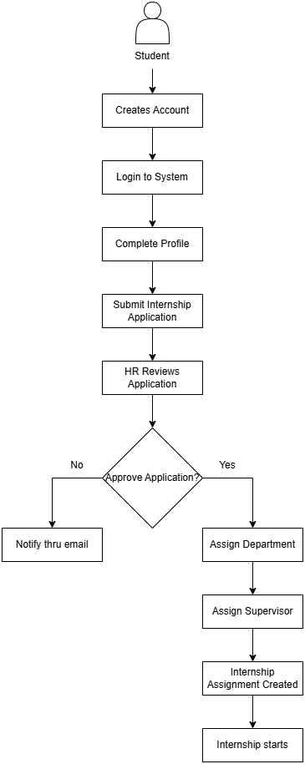
Figure 1. Internship Onboarding Workflow
Phase 2 - Internship Management
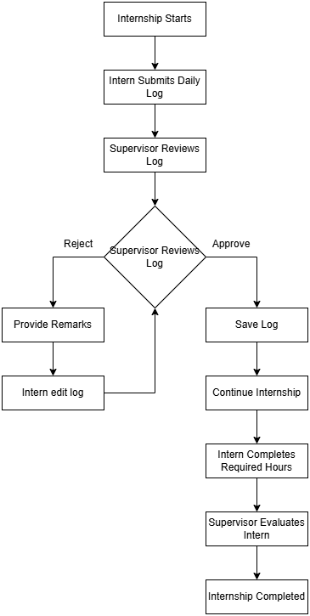
Figure 2. Internship Management Workflow

Workflow Summary Table
Phase | Responsible User | Activity
Registration | Intern | Create account and login
Profile Management | Intern | Complete personal profile
Application | Intern | Submit internship application
Document Submission | Intern | Upload required documents
Verification | HR | Review and verify documents
Approval | HR | Approve or reject application
Assignment | HR | Assign department and supervisor
Monitoring | Intern & Supervisor | Submit and review daily logs
Evaluation | Supervisor | Evaluate intern performance
Completion | HR | Mark internship as completed

5. Use Cases

5.1 Actors
The Internship Management System consists of four primary actors.

Actor | Description
Intern | Creates an account, submits internship applications, uploads requirements, submits daily logs, and monitors internship progress.
Human Resources Personnel | Reviews applications, verifies requirements, assigns departments and supervisors, and manages internship records.
Supervisor | Reviews daily logs, monitors assigned interns, and performs performance evaluations.
System Administrator | Manages user accounts, user roles, departments, and system configuration.

5.2 Major Use Cases

Use Case | Primary Actor
Register Account | Intern
Login | All Users
Manage Profile | Intern
Submit Internship Application | Intern
Upload Requirements | Intern
View Application Status | Intern
Review Applications | HR Personnel
Review Requirements | HR Personnel
Approve or Reject Application | HR Personnel
Assign Internship | HR Personnel
Submit Daily Log | Intern
Review Daily Log | Supervisor
Evaluate Intern | Supervisor
View Assigned Interns | Supervisor
Post Announcement | HR Personnel / System Administrator
Manage Users | System Administrator
Manage Roles | System Administrator
Manage Departments | System Administrator
Logout | All Users

5.3 Use Case Descriptions
UC-01 Register Account

Item | Description
Actor | Intern
Description | Allows an intern to create a system account.
Precondition | The intern is not yet registered.
Postcondition | A user account and intern profile are created.

UC-02 Submit Internship Application
Item | Description
Actor | Intern
Description | Allows interns to apply for an internship.
Precondition | The intern has completed their profile.
Postcondition | A new internship application is recorded with a status of "Pending."

UC-03 Upload Requirements
Item | Description
Actor | Intern
Description | Allows interns to upload the required internship documents.
Precondition | An internship application exists.
Postcondition | Uploaded documents are stored for HR review.

UC-04 Review Application
Item | Description
Actor | Human Resources Personnel
Description | Reviews internship applications and submitted documents.
Precondition | An application has been submitted.
Postcondition | The application is approved or rejected.

UC-05 Assign Internship
Item | Description
Actor | Human Resources Personnel
Description | Assigns the approved intern to a department and supervisor.
Precondition | The internship application has been approved.
Postcondition | An internship assignment is created.

UC-06 Submit Daily Log
Item | Description
Actor | Intern
Description | Allows interns to submit their daily accomplishment logs.
Precondition | The intern has an active internship assignment.
Postcondition | A daily log is recorded.

UC-07 Evaluate Intern
Item | Description
Actor | Supervisor
Description | Allows supervisors to evaluate intern performance.
Precondition | The intern has completed internship activities.
Postcondition | Evaluation scores and remarks are recorded.

6. Entity Relationship Diagram (ERD)

6.1 Overview
The Entity Relationship Diagram (ERD) illustrates the logical database structure of the proposed Internship Management System. It defines the entities, their attributes, and the relationships required to support the complete internship lifecycle, from student registration to internship completion.
The database follows normalization principles to minimize data redundancy while maintaining data integrity and supporting efficient data retrieval.
The primary entities of the system include:
- Roles
- Users
- Interns
- Departments
- Supervisors
- Applications
- Requirements
- Submissions
- Assignments
- Daily Logs
- Evaluations
- Announcements
The Users table serves as the central authentication entity and is linked to role-specific information through the Interns and Supervisors tables. Internship applications are associated with requirement submissions, while approved applications generate internship assignments. During the internship period, interns submit daily accomplishment logs that are reviewed by supervisors, who also conduct performance evaluations. Authorized users may create announcements to communicate important information throughout the internship program.
The relationships among these entities ensure that the proposed system accurately represents the organization's internship workflow while maintaining data consistency and scalability for future enhancements.
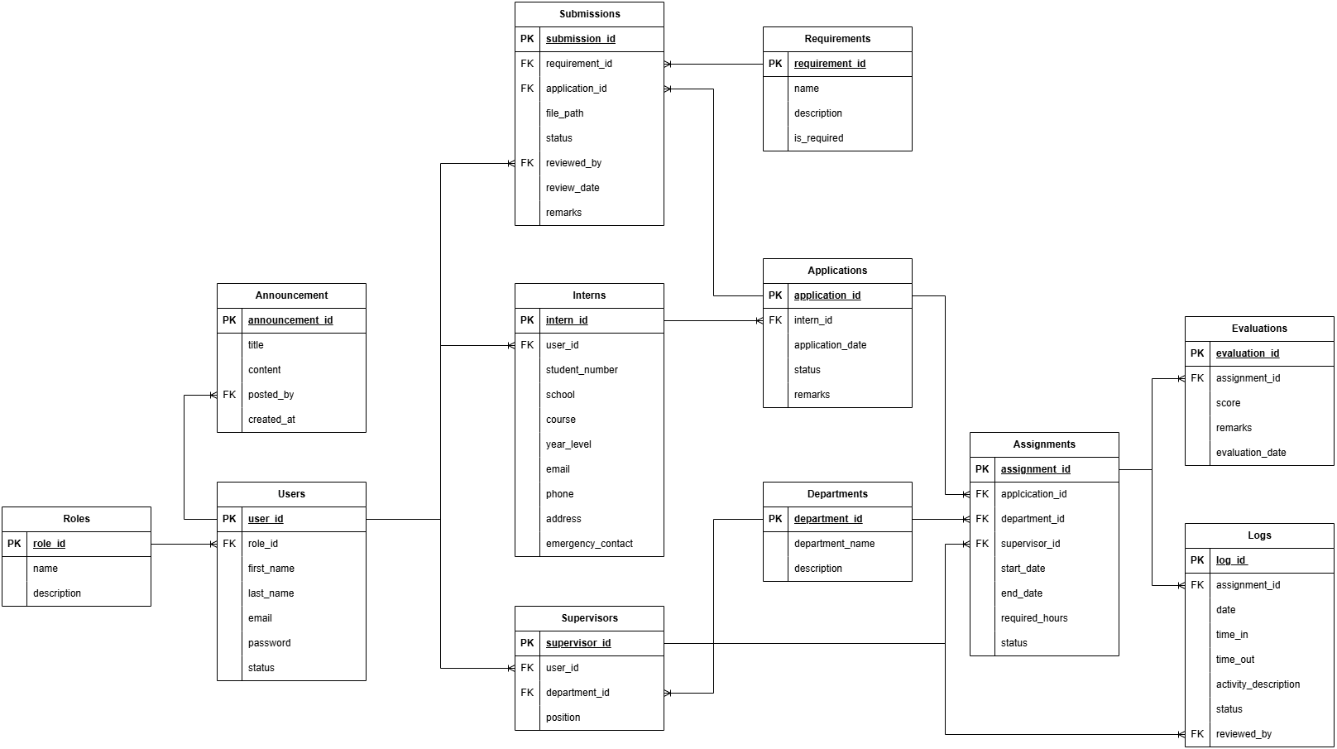
Figure 3. Entity Relationship Diagram of the Proposed Internship Management System

7. Data Dictionary

6.1 Roles Table
Description: Stores the different user roles in the system.

Field | Data Type | Constraints | Description
role_id | BIGINT | PK, Auto Increment | Unique identifier of the role
role_name | VARCHAR(50) | NOT NULL, UNIQUE | Name of the role (Admin, HR, Supervisor, Intern)
created_at | TIMESTAMP | NULL | Record creation timestamp
updated_at | TIMESTAMP | NULL | Record update timestamp

6.2 Users Table
Description: Stores authentication and account information for all users.

Field | Data Type | Constraints | Description
user_id | BIGINT | PK, Auto Increment | Unique user identifier
role_id | BIGINT | FK → roles.role_id | User role
first_name | VARCHAR(100) | NOT NULL | User's first name
last_name | VARCHAR(100) | NOT NULL | User's last name
email | VARCHAR(255) | UNIQUE, NOT NULL | User email
password | VARCHAR(255) | NOT NULL | Encrypted password
status | ENUM | Active, Inactive | Account status
created_at | TIMESTAMP | NULL | Record creation timestamp
updated_at | TIMESTAMP | NULL | Record update timestamp

6.3 Interns Table
Description: Stores intern-specific information.

Field | Data Type | Constraints | Description
intern_id | BIGINT | PK | Intern ID
user_id | BIGINT | FK → users.user_id | Linked user account
student_number | VARCHAR(30) | NOT NULL | Student number
school | VARCHAR(150) | NOT NULL | School name
course | VARCHAR(100) | NOT NULL | Course enrolled
year_level | INT | NOT NULL | Current year level
phone | VARCHAR(20) | NULL | Contact number
address | TEXT | NULL | Home address
emergency_contact | VARCHAR(100) | NULL | Emergency contact
created_at | TIMESTAMP | NULL | Record creation
updated_at | TIMESTAMP | NULL | Record update

6.4 Departments Table
Description: Stores company departments.

Field | Data Type | Constraints | Description
department_id | BIGINT | PK | Department ID
department_name | VARCHAR(100) | NOT NULL | Department name
description | TEXT | NULL | Department description
created_at | TIMESTAMP | NULL | Record creation
updated_at | TIMESTAMP | NULL | Record update

6.5 Supervisors Table
Description: Stores supervisor information.

Field | Data Type | Constraints | Description
supervisor_id | BIGINT | PK | Supervisor ID
user_id | BIGINT | FK → users.user_id | Linked user
department_id | BIGINT | FK → departments.department_id | Assigned department
position | VARCHAR(100) | NOT NULL | Job position
created_at | TIMESTAMP | NULL | Record creation
updated_at | TIMESTAMP | NULL | Record update

6.6 Applications Table
Description: Stores internship applications.

Field | Data Type | Constraints | Description
application_id | BIGINT | PK | Application ID
intern_id | BIGINT | FK → interns.intern_id | Applicant
application_date | DATE | NOT NULL | Date submitted
status | ENUM | Pending, Approved, Rejected | Application status
remarks | TEXT | NULL | HR remarks
created_at | TIMESTAMP | NULL | Record creation
updated_at | TIMESTAMP | NULL | Record update

6.7 Requirements Table
Description: Master list of required internship documents.

Field | Data Type | Constraints | Description
requirement_id | BIGINT | PK | Requirement ID
requirement_name | VARCHAR(100) | NOT NULL | Name of document
description | TEXT | NULL | Requirement description
is_required | BOOLEAN | DEFAULT TRUE | Indicates whether the document is mandatory
created_at | TIMESTAMP | NULL | Record creation
updated_at | TIMESTAMP | NULL | Record update

6.8 Submissions Table
Description: Stores uploaded internship documents.

Field | Data Type | Constraints | Description
submission_id | BIGINT | PK | Submission ID
application_id | BIGINT | FK → applications.application_id | Related application
requirement_id | BIGINT | FK → requirements.requirement_id | Required document
file_path | VARCHAR(255) | NOT NULL | File location
status | ENUM | Pending, Approved, Rejected | Review status
remarks | TEXT | NULL | HR remarks
reviewed_by | BIGINT | FK → users.user_id | HR reviewer
reviewed_at | DATETIME | NULL | Review date
created_at | TIMESTAMP | NULL | Upload timestamp
updated_at | TIMESTAMP | NULL | Record update

6.9 Assignments Table
Description: Stores approved internship assignments.

Field | Data Type | Constraints | Description
assignment_id | BIGINT | PK | Assignment ID
application_id | BIGINT | FK → applications.application_id, UNIQUE | Approved application
department_id | BIGINT | FK → departments.department_id | Assigned department
supervisor_id | BIGINT | FK → supervisors.supervisor_id | Assigned supervisor
start_date | DATE | NOT NULL | Internship start
end_date | DATE | NOT NULL | Internship end
required_hours | INT | NOT NULL | Required internship hours
completed_hours | INT | DEFAULT 0 | Completed internship hours
status | ENUM | Active, Completed | Assignment status
created_at | TIMESTAMP | NULL | Record creation
updated_at | TIMESTAMP | NULL | Record update

6.10 Logs Table
Description: Stores interns' daily accomplishment logs.

Field | Data Type | Constraints | Description
log_id | BIGINT | PK | Log ID
assignment_id | BIGINT | FK → assignments.assignment_id | Internship assignment
log_date | DATE | NOT NULL | Work date
time_in | TIME | NOT NULL | Time in
time_out | TIME | NOT NULL | Time out
activity_description | TEXT | NOT NULL | Daily accomplishments
status | ENUM | Pending, Approved, Rejected | Review status
reviewed_by | BIGINT | FK → supervisors.supervisor_id | Reviewing supervisor
reviewed_at | DATETIME | NULL | Review timestamp
created_at | TIMESTAMP | NULL | Record creation
updated_at | TIMESTAMP | NULL | Record update

6.11 Evaluations Table
Description: Stores supervisor evaluations.

Field | Data Type | Constraints | Description
evaluation_id | BIGINT | PK | Evaluation ID
assignment_id | BIGINT | FK → assignments.assignment_id | Internship assignment
score | DECIMAL(5,2) | NOT NULL | Evaluation score
remarks | TEXT | NULL | Supervisor comments
evaluation_date | DATE | NOT NULL | Evaluation date
created_at | TIMESTAMP | NULL | Record creation
updated_at | TIMESTAMP | NULL | Record update

6.12 Announcements Table
Description: Stores organization announcements.

Field | Data Type | Constraints | Description
announcement_id | BIGINT | PK | Announcement ID
title | VARCHAR(255) | NOT NULL | Announcement title
content | TEXT | NOT NULL | Announcement details
posted_by | BIGINT | FK → users.user_id | User who posted
created_at | TIMESTAMP | NULL | Date posted
updated_at | TIMESTAMP | NULL | Record update

7. System Architecture

7.1 System Architecture Overview
The proposed Internship Management System follows a three-tier web application architecture consisting of the Presentation Layer, Application Layer, and Data Layer. This architecture promotes modularity, maintainability, scalability, and separation of concerns.
The system is developed using the Laravel Framework, which implements the Model-View-Controller (MVC) architectural pattern. Through MVC, user requests are processed by controllers, business logic is handled through models and services, and information is presented through views.
The architecture allows interns, Human Resources personnel, supervisors, and system administrators to access the system through a web browser while interacting with a centralized database.

7.2 Architectural Components
Presentation Layer (Client Layer)
The Presentation Layer serves as the user interface of the system.

Functions include:
- User authentication
- Profile management
- Application submission
- Requirement uploads
- Daily log submission
- Evaluation viewing
- Announcement viewing
Technologies:
- HTML5
- CSS3
- JavaScript
- Bootstrap/Tailwind CSS
- Laravel Blade Templates

Application Layer (Business Logic Layer)
The Application Layer processes user requests and implements business rules.

Functions include:
- Authentication and authorization
- Application processing
- Requirement verification
- Internship assignment management
- Daily log management
- Performance evaluation processing
- Announcement management
Technologies:
- PHP
- Laravel Framework
- Laravel Controllers
- Laravel Middleware
- Laravel Services

Data Layer (Database Layer)
The Data Layer stores and manages all internship-related information.

Functions include:
- User management
- Internship records
- Requirement submissions
- Internship assignments
- Daily logs
- Evaluations
- Announcements
Technologies:
- MySQL Database Management System

7.3 System Architecture Diagram
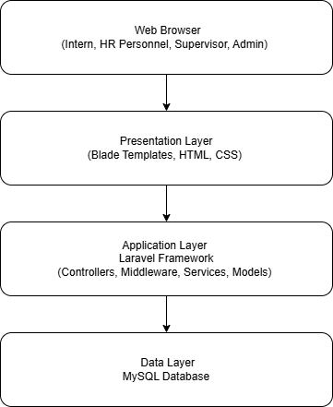
Figure 4. System Architecture Diagram
Architectural Benefits
The proposed architecture provides the following benefits:
- Separation of concerns through MVC architecture
- Improved maintainability and code organization
- Enhanced scalability for future features
- Centralized data management
- Improved security through Laravel authentication and middleware

